Hindi and Hinglish Depression Meme Dataset

Feeling Sad, Empty, or Hopeless
Meme 1

Source: https://in.pinterest.com/pin/676102962800450852/

Meme 2
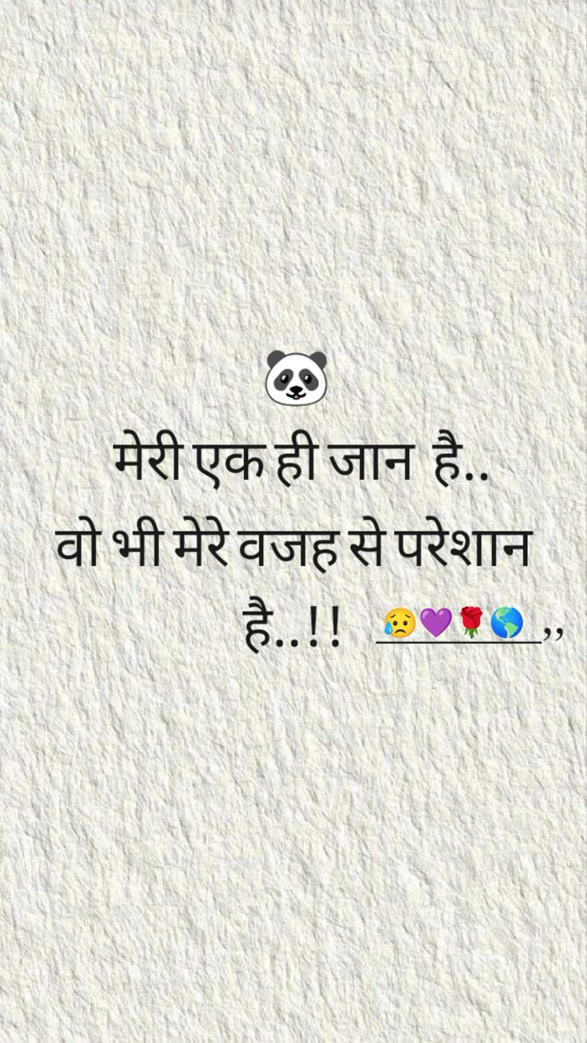
Source: https://in.pinterest.com/pin/676736281541723954/

Meme 3
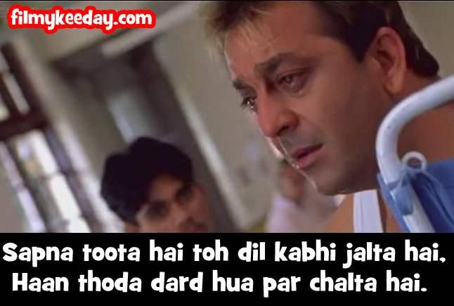
Source: https://in.pinterest.com/pin/641270434410696254/

Meme 4

Source: https://in.pinterest.com/pin/949837377635641327/

Meme 5

Source: https://in.pinterest.com/pin/595390013275939282/

Meme 6
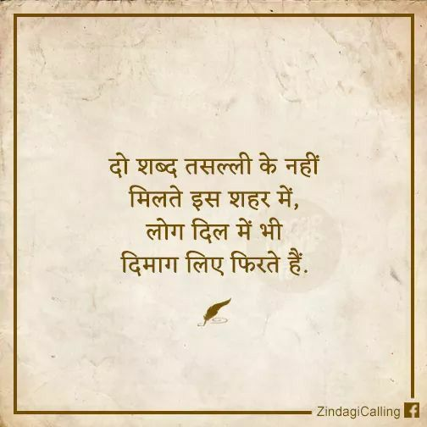
Source: https://in.pinterest.com/pin/102034747799519403/

Meme 7
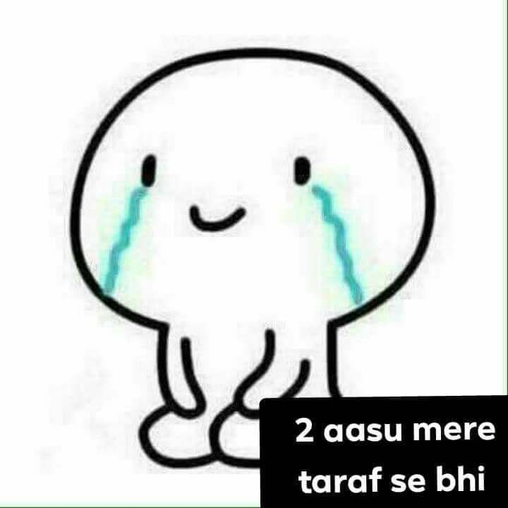
Source: https://in.pinterest.com/pin/655273814519515178/

Meme 8
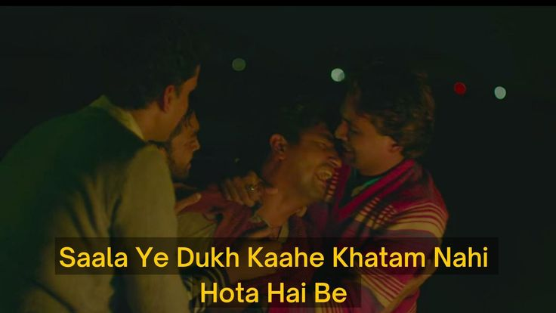
Source: https://in.pinterest.com/pin/664703226267054731/

Meme 9
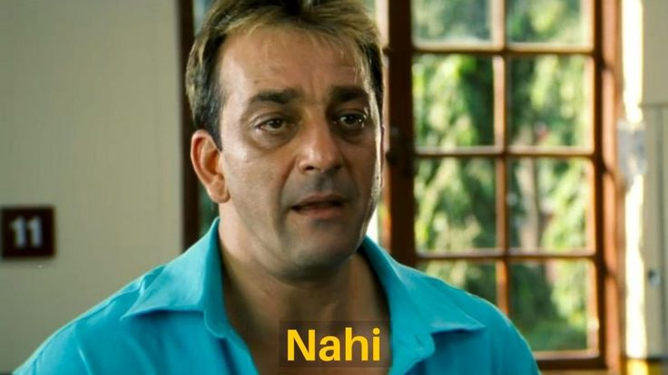
Source: https://in.pinterest.com/pin/580401470734087599/

Meme 10
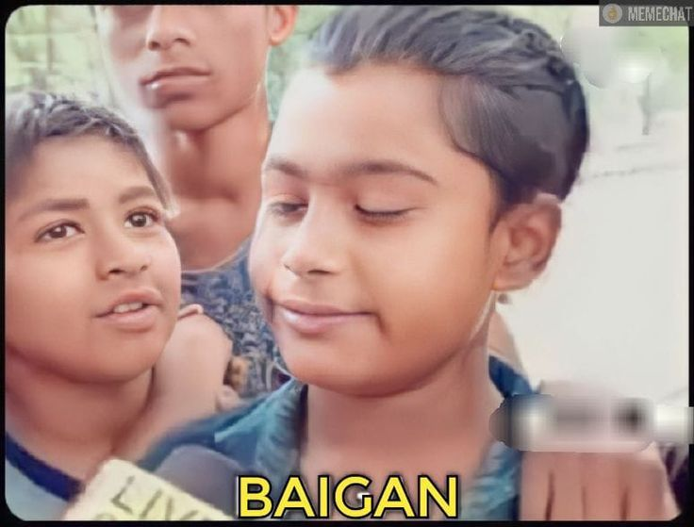
Source: https://in.pinterest.com/pin/74450200083820463/

Loss of Interest or Pleasure
Meme 11

Source: https://in.pinterest.com/pin/640144534568164493/

Sleep Problems
Meme 12
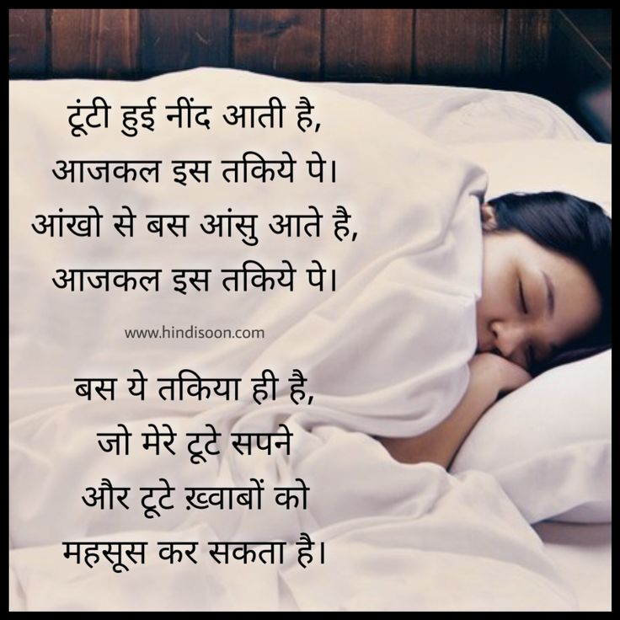
Source: https://in.pinterest.com/pin/658158933056580057/

Meme 13

Source: https://in.pinterest.com/pin/599119556708899141/

Meme 14
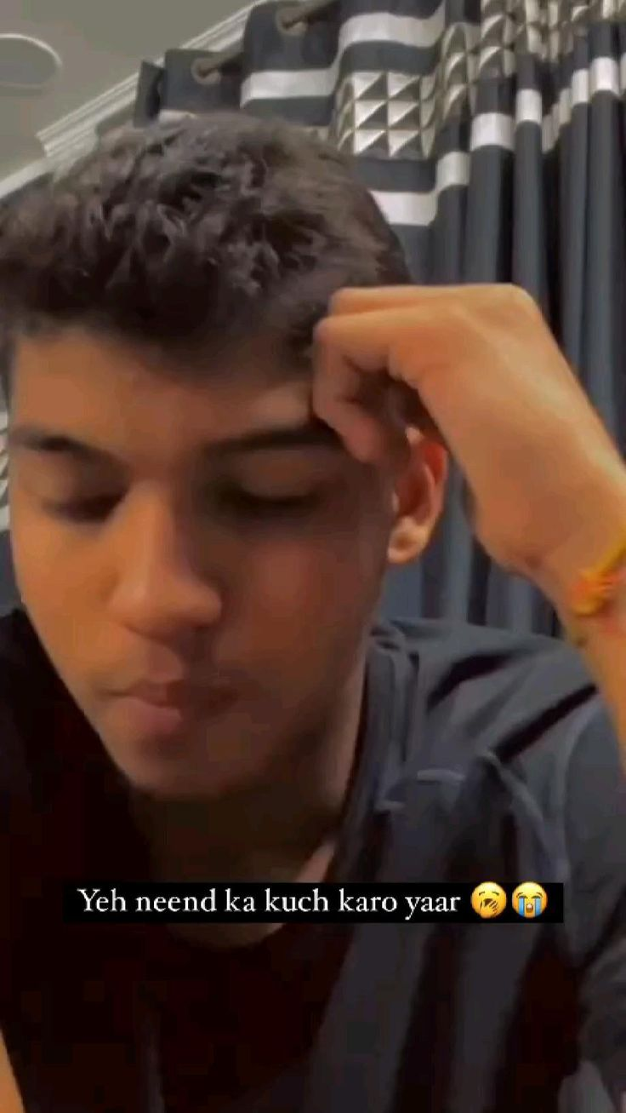
Source: https://in.pinterest.com/pin/606156431116996471/

Low Energy or Fatigue
Meme 15

Source: https://in.pinterest.com/pin/781444972855813495/

Meme 16
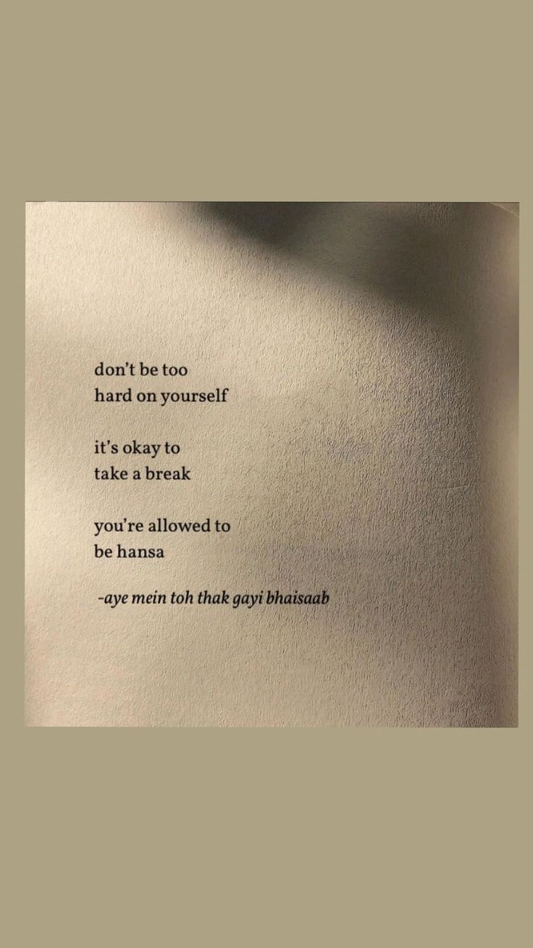
Source: https://in.pinterest.com/pin/907545762389465441/

Meme 17
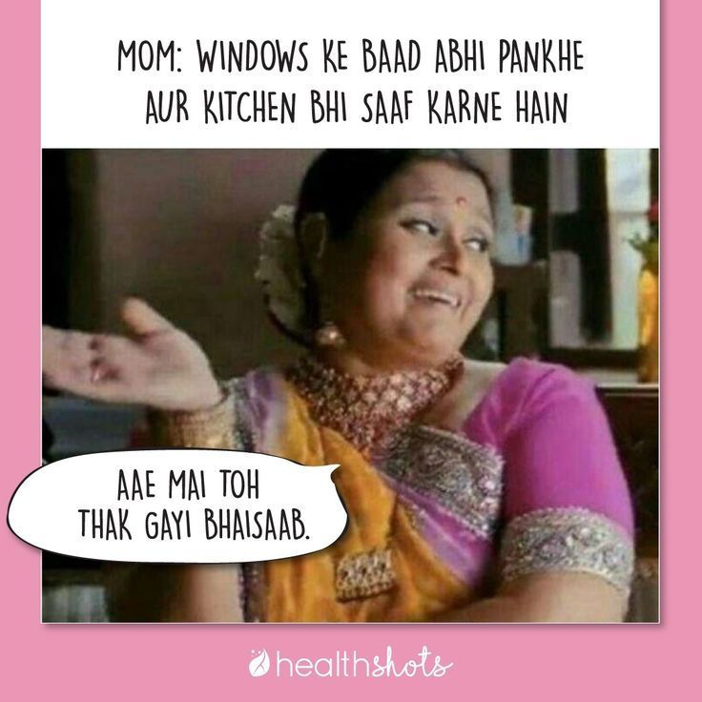
Source: https://in.pinterest.com/pin/735634920399701861/

Feelings of Worthlessness or Guilt
Meme 18

Source: https://in.pinterest.com/pin/787144841125717318/

Meme 19
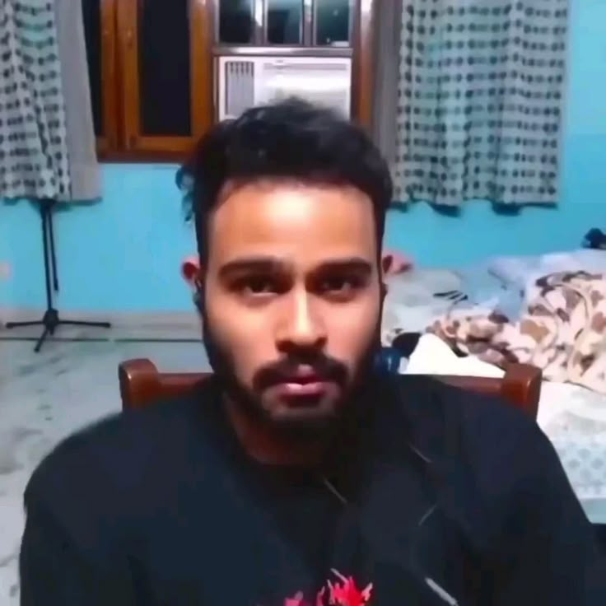
Source: https://in.pinterest.com/pin/912119730775204627/

Meme 20
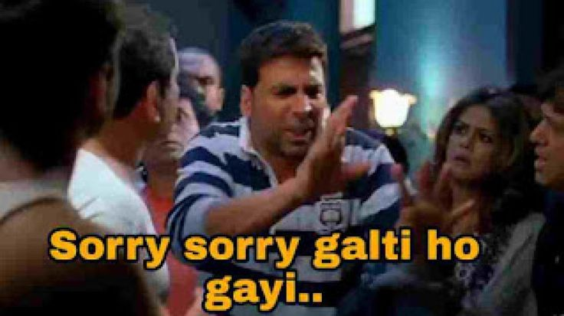
Source: https://in.pinterest.com/pin/905927281278201573/

Meme 21
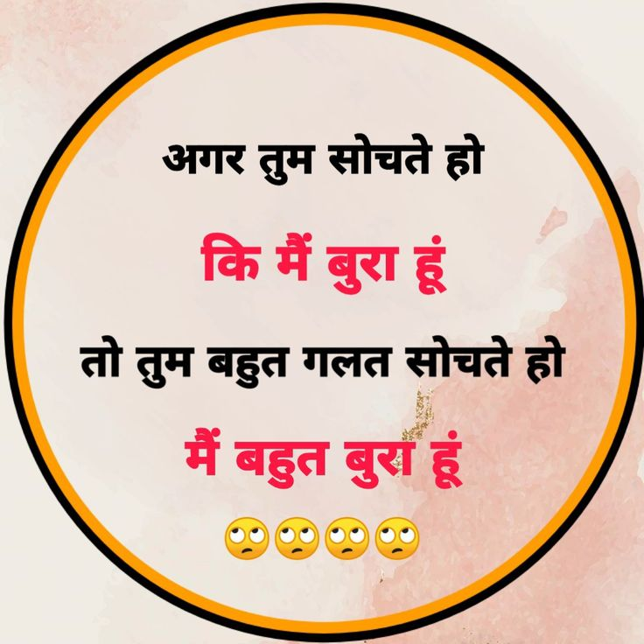
Source: https://in.pinterest.com/pin/616852480199658328/

Difficulty Concentrating
Meme 22
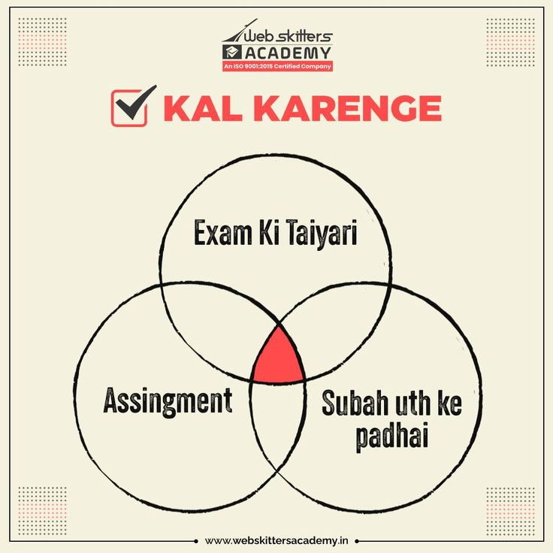
Source: https://in.pinterest.com/pin/492581278010011006/

Meme 23
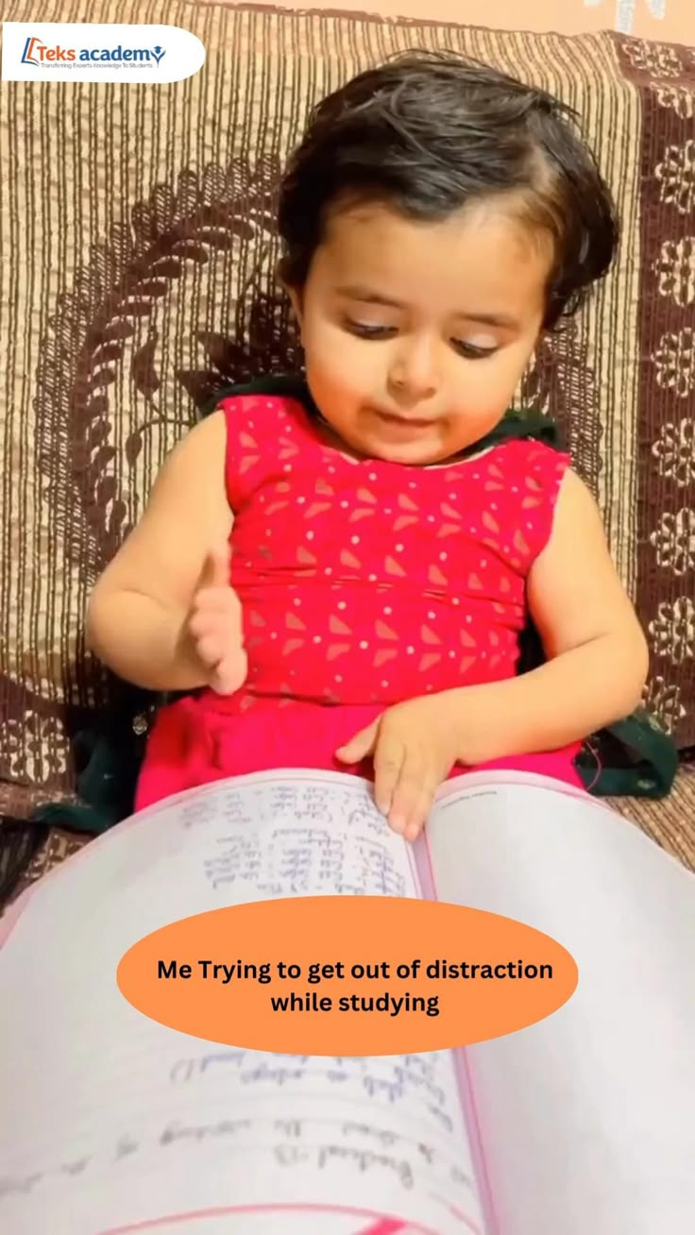
Source: https://in.pinterest.com/pin/316448311338721481/

Meme 24
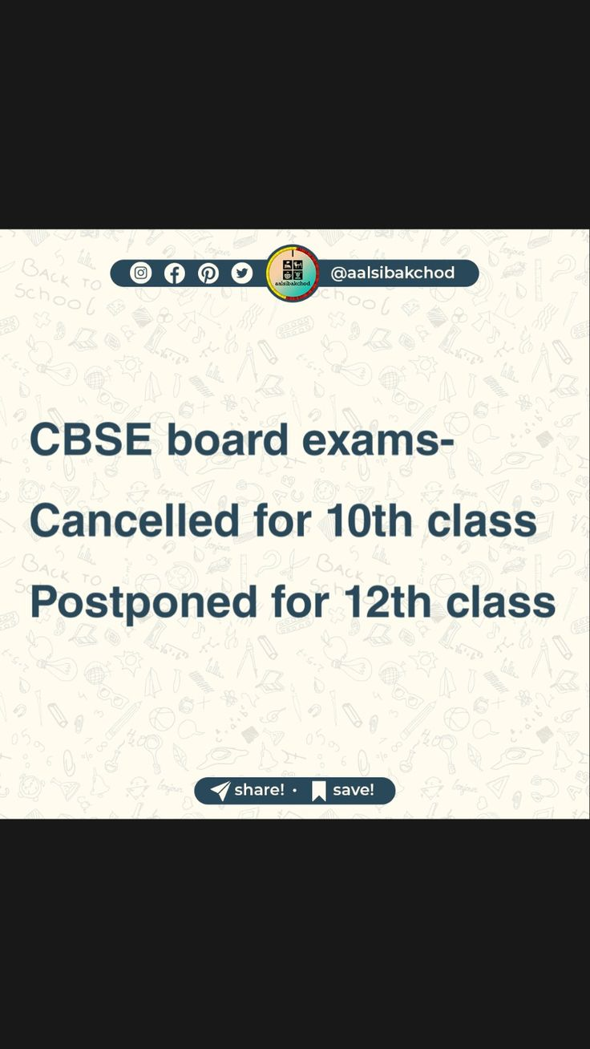
Source: https://in.pinterest.com/pin/619807967472587474/

Meme 25
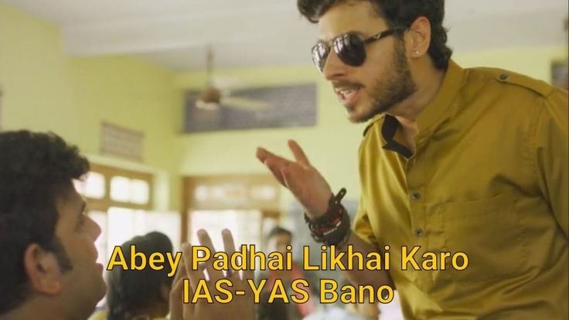
Source: https://in.pinterest.com/pin/986077280881518762/

Slowed Movement or Restlessness
Meme 26
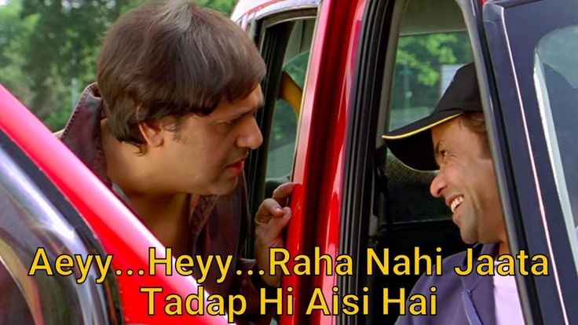
Source: https://in.pinterest.com/pin/989384611870121680/

Meme 27
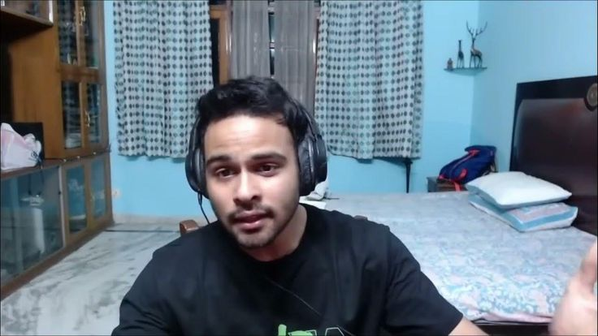
Source: https://in.pinterest.com/pin/1001136192160263000/

Meme 28
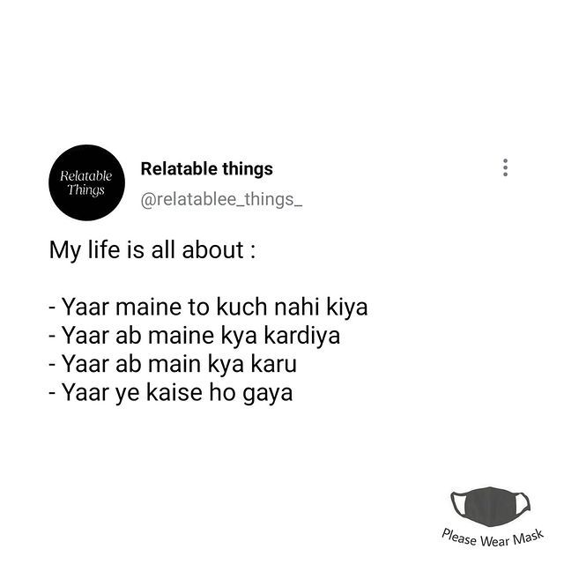
Source: https://in.pinterest.com/pin/610097080772804643/

Thoughts About Death or Self-Harm
Meme 29

Source: https://in.pinterest.com/pin/714172453413063167/

Meme 30

Source: https://in.pinterest.com/pin/767652698981595331/

Meme 31
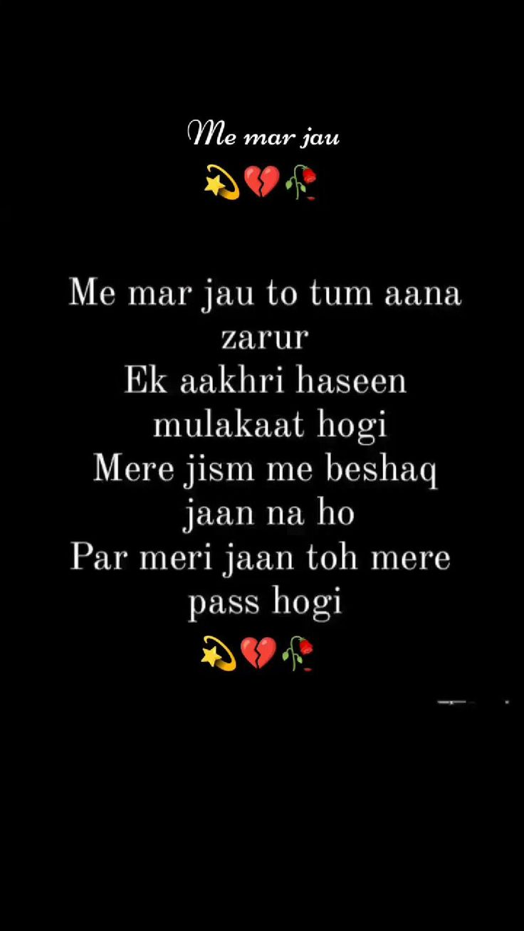
Source: https://in.pinterest.com/pin/731342427006601515/

